Three Blondes Brewing Donation Form
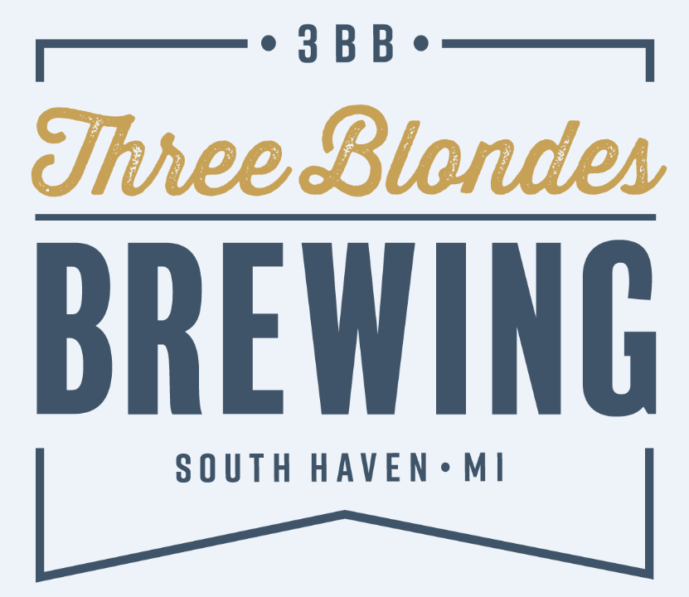
Since opening in June of 2018, 3BB has been committed to giving back to South Haven and the Southwest Michigan community that has supported us through our development and opening. As much as we want to be involved and engaged in everything, at the end of the day we still need to make great beer so there are natural limits to what we can commit ourselves to.
3BB Rules of the Road:
- Due to Michigan state law, we are not legally allowed to donate beer to events. We legally cannot make any exceptions.
- We do not partner with religious organizations, sports teams, individual athletes, bands or golf outings.
- Any events submitted with less than 2 months’ notice will be omitted automatically. We want to ensure the quality of our involvement is top notch.
For consideration, please fill out this form entirely. We receive submissions constantly and need sufficient information for your event to make an informed decision. Please know that we give extra weight to requests where…
1) A 3BB Staff Member is personally involved
2) The beneficiaries of the request reside in Van Buren County

Event Date: _______________
Organization Name: ___________________________________________________________________
Are you a Non-Profit? Yes or No (If Yes please provide Tax ID# ______________________)
Contact Name: _________________________________________________________________
Address: ______________________________________________________________________
Email: ________________________________________________________________________
Phone: _______________________________________________________________________
1) We are seeking (Check all that apply):
- Financial Contribution Exact Amount: $________________
- Donated Material (Please attach a material list)
- Discount on Material (Please attach a material list)
- Other (Please Specify): _______________________________________________________
2) Please briefly explain your request: ______________________________________________________________________________
______________________________________________________________________________
______________________________________________________________________________
3) Who specifically will benefit and how?
______________________________________________________________________________
______________________________________________________________________________
______________________________________________________________________________
4) Do any of the beneficiaries reside in Van Buren County, if so where?
______________________________________________________________________________
______________________________________________________________________________
5) Are any 3BB Staff directly involved in your organization? (Please list names):
______________________________________________________________________________
______________________________________________________________________________
6) Will Three Blondes Brewing be recognized, if so in what way?
______________________________________________________________________________
______________________________________________________________________________
______________________________________________________________________________
7) Is there a deadline we should be aware of?_________________________________________

Please complete this form a minimum of two months prior to your deadline. Also, if we are able to help we would appreciate a thank you letter or a picture to post on our webpage.
Three Blondes Brewing ● South Haven, MI 49090 ● 269.872.3911 ● www.threeblondesbrewing.com

